ONE SYSTEM MERIT

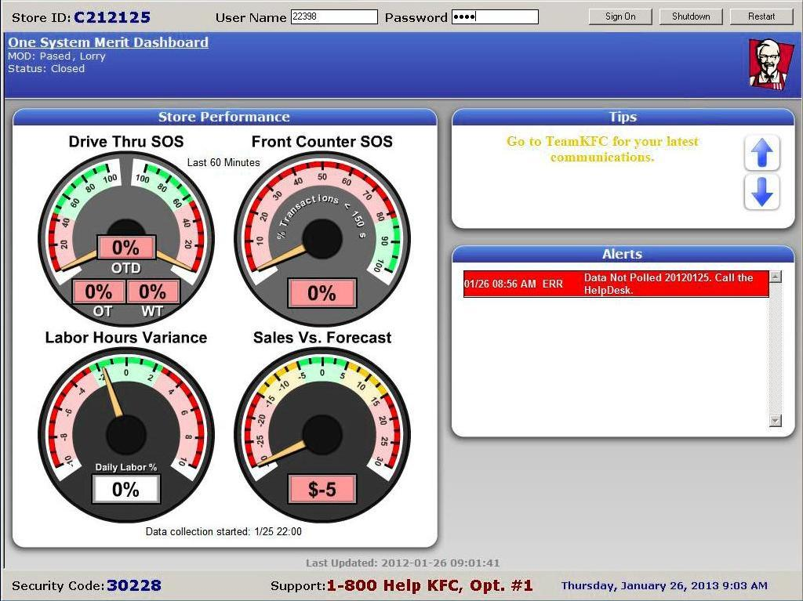

Compris IBM Overnight
New Store Installation Instructions

05/09/2012

Table of Contents
Overview 3
KFC Install Contacts: 3
Arriving at the Store 3
Installation Start 4
PC Data Installation Process – Dell Server 6
DELL 790 - important BIOS settings to verify 7
Staging ALL POS on front counter 14
Deinstalling old POS 17
Move Equipment to Permanent Locations 17
Install BOH Printer 17
SOD on POS 21
KDS – Kitchen Monitor Installation 21
Setting IDs on ePics 24
VIDEO DIAGNOSTICS 24
Ring-up mock orders: TEST POS, MONITORS & BUMP PADS 25
Instructions for Enabling Pin Pad Software (Ingenico Cashless Payment Devices) 29
Data cabling 32
T-568B 32
Back Office Installation 33
POS Installation 34
Cash Drawer Brackets 36
Cashless Pinpad Kit Hardware Install 40
Configuring OKI MFP 480 password, fax, ring response 46
Cleanup Tasks 47
Trouble Shooting Aids 49
APPENDIX 1 Sample Office Layout 51
APPENDIX 2 Network Cabinet 52
APPENDIX 3 IBM POS Ports 53
APPENDIX 4 DELL Bios Screen Shot 54

ONE SYSTEM MERIT Compris Overnight New Store Install Overview
The installation will include removing all of the existing POS equipment, installing new network cabling, electrical outlets (if required), and installing a new POS system.
Installs will primarily occur Sunday through Wednesday night from 10:00pm to 8:00am. All equipment will be delivered to the store the business day before the install
A configuration sheet will be included which will indicate what POS, Kitchen Displays, and printers need to be installed.

Overview
- Take Inventory – verify ordered equipment arrived to build a working system for the next day
- Download &Staging - set up one of the two Switches, the DELL PC, and all POS on the Front Counter and begin a Data Download & initial POS stage.
- Wiring Cabinet - install in the office at least 6” from the ceiling
- CAT5 Cabling – run Home Run cables in the ceiling from the Patch panel to the RJ45 jacks for each POS, Epic & Pinpad.
- Brackets – Install brackets for Monitors. Get a good start on any hanging (Ceiling) brackets as they can be time consuming.
- Registers, Cash Drawers, & Receipt Printers – install in permanent locations assuming initial data download was successful. De-install old POS system as needed once new POS have initial staging completed.
- Pack Monitors, ePic Controllers, & Bumpbars – connect all Pack Monitors & Bumpbars to the Epic Controllers
- Staging Portion Continued
- Ringup Testing
- Install Biometrics
- Install Cashless Pinpads

KFC Install Contacts:
KFC Install Desk (502)874-1880 (toll Free 800-544-5774 ext 1880)
Note: This Installation Line is open Sunday 10pm EST through Thursday 11am EST. If calling outside these open hours please call: the KFC Help Desk Tech line@ 800 544 5774 ext 8883

Arriving at the Store
The Team leader should arrive at the site shortly before store closing and provide Identification to the Store Manager.
Ensure the following with the Store Manager:
- Ask for the emergency home/pager/cell numbers for the manager on duty in case you need to contact them during the night.
- Ask the Manager to inform you when their End of Day process is complete. They need to stay until the End of Day process is complete.
- Ensure they have removed the money from the old cash drawers before leaving.
- Confirm procedures for someone to exit and enter the store during the night without setting the alarm off.
Installation Start – Prior to End of Day process complete
DO NOT REMOVE EXISTING EQUIPMENT UNTIL DATA DOWNLOAD IS COMPLETE and new POS have staged successfully
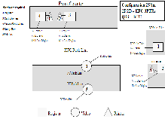
When the technicians first arrive show the installation diagram to the on-site manager.
- Go over the location (height/angle/direction/etc.) of each monitor with the manager using the configuration layout as a guide.
- Test each arm mounting location with a stud finder. If a monitor is already in the position, test the bracket for strength and examine the wall location to ensure the new bracket can be installed safely. Make sure that the wood at that location is not rotten, and identify the best anchors from the selection, for each wall bracket location. Remember that if the bracket is loose or unsafe, it may fall on someone and injure them.
- If the manager wishes the monitors to go in a different position, that position must be tested, *while* the manager is there
- If any location for a bracket or monitor is deemed to be unsafe, the manager will be informed and given the opportunity to provide an alternate installation location. Should the manager be unhappy with the movement of the bracket/ or installation of the bracket, due to safety, you should immediately call KFC Install Contacts listed at the beginning of this document. They will give direction on what should be done next. As an installer, you are *never* to argue with the manager, instead refer the manager to KFC Install Contact.
- Please document which monitors were moved in paperwork and what the safety reasons were for doing so.

- Start unpacking equipment and take an inventory count. It should be compared against the inventory sheet.
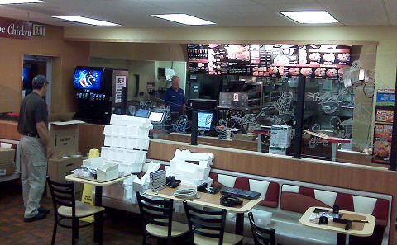
- Review and scope what network drops and if applicable, what additional electrical outlets are needed. The location of the new brackets should be identified at this time.
- Set the following equipment up on the Front Counter for the Data download Process & Staging (with surge strips and extension cords as necessary) in preparation for the conversion process:
- POS terminals Ensure all POS devices are plugged into power but remain TURNED OFF until the staging process begins. (If terminals power up when plugged in, turn them off by pressing the power button.) Label each POS per the configuration sheet. If a training terminal was delivered ahead of time, it should also be set up on the front counter. Peripherals(Cash drawer, Receipt Printer, etc.) do not need to be connected until moving to permanent location as directed later in this document.
- New Dell PC, Monitor, Mouse and Keyboard - Plug the keyboard and mouse to the back of the PC in any USB port. Leave powered off until instructed to power on below. Attach the clear protector overlay to the keyboard if provided.
- Office Printer – will not be set up until later, in the office
- Using LAN patch cables, attach all POS terminals and Dell PC to the switch using any ports 1-19. (The Secondary Switch will be connected later, in the cabinet in the office)
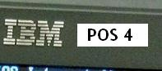
- Label each of the terminals using the supplied stickers. The label should be put on the terminal to the right of the IBM Logo.
(When the Manager informs you that the End of Day process has completed, immediately proceed with the Dell PC installation process.)
- Verify that all POS and Video controllers are powered off at this time.

PC Data Installation Process – Dell Server
DSL Connectivity Connect the supplied 75ft Red Cat5 Ethernet “tester” cable from Port 0 on the Cisco 891 router in the office to the port 26T port on the HP ProCurve switch sitting on the front counter. Port “WAN GE 0” should connect to the DSL wall jack in the office (or local DSL Router for “Broadband Of Choice” sites). Either way, 26T must be supplied with a live internet signal for success.
Each HP ProCurve will automatically stage itself in about five minutes after being powered up and connected to the internet – IF NOT ALREADY STAGED.
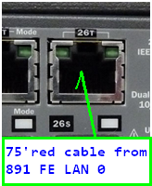
The blue “Locator” light is designed to stay lit for the next several hours once staged…
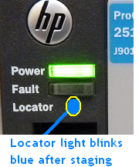

Turn on the New Dell 790 computer and verify the BIOS Settings.
(Note: this must be done prior to starting the Store Install Process)
Immediately press the F2 key until the message “Entering Setup” appears at the top right corner of the screen.
Verify the following BIOS settings are set – CALL KFC INSTALL CONTACTS to report IF any major differences found before proceeding! If correct, proceed on.

DELL 790 - important BIOS settings to verify
General
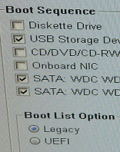
Boot Sequence –
Check: USB and BOTH SATA’s
Diskette Drive (should already be unchecked)
CD/DVD/CD-RWR Drive(should already be unchecked)
Onboard NIC(should already be unchecked)

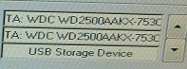
Boot List Option
Legacy Boot (should already be checked, UEFI unchecked)
ORDER on right: SATA drives (1 & 2) then USB Storage Device

System Configuration
Integrated NIC – Enabled (Enable Checked, others not checked)
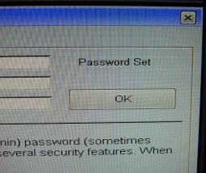
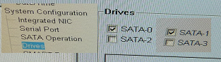
SATA Operation – ATA MODE
Drives – SATA-0 Checked
SATA-1 Checked
SATA-2 UnChecked
SATA-3 UnChecked
Security
Admin Password – should say “Password Set”
TPM Security – Disabled (Unchecked)
Computrace(R) – Deactivate (Deactivate Checked)
Performance
Multi Core Support – ALL

Once the Bios settings have been confirmed, click Exit in bottom right hand corner and the PC will reboot.
- Once the PC boots up, Double Click on Install Icon in the upper left corner of the screen.
- When the following screen appears, click YES to start the Store Install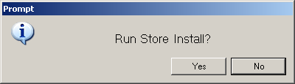.
- The following window will appear in the lower right corner of the screen; this window will display the status of the steps being completed during the Install.
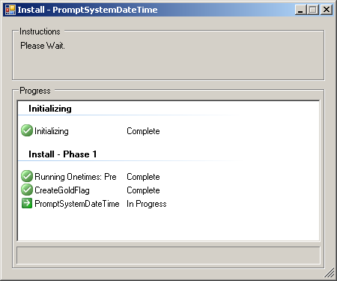
- Next the following prompt will display, click OK. 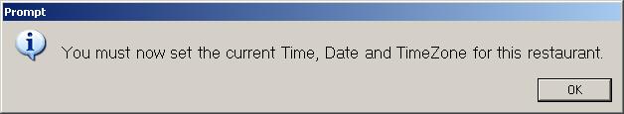5) The following screen will appear: 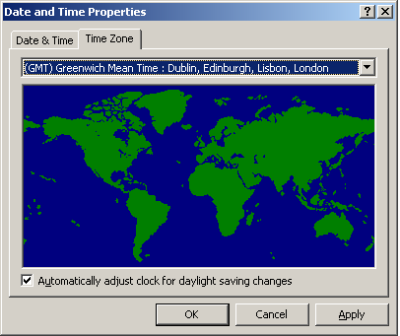
Note on the “Automatically adjust clock” box…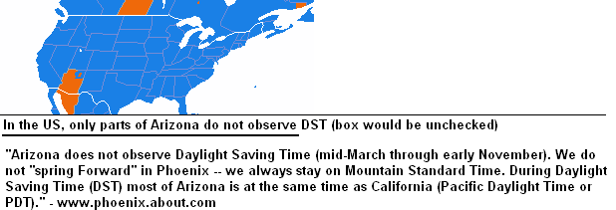
- Click on the drop down arrow and select the appropriate time zone for the store as displayed in the example below:
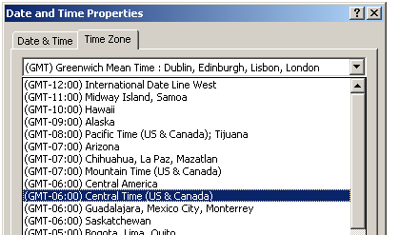
- Once the appropriate time zone has been selected, click Apply.
- Click on the Date and Time tab. Note: Both the Date and Time may be different due to changing the Time Zone.
- Change the Date and Time back to the current date and time, click Apply.
- Once the Date and Time has been corrected, click OK.
- The following prompt will appear to confirm the Date, Time and Time Zone.
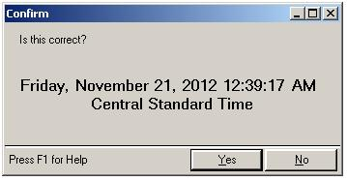
- If the Date, Time or Time Zone is incorrect then click NO to return to the Date and Time properties to correct, otherwise click Yes to continue with the Store Install Process.
- The PC will reboot to apply the changes made.
- Once the PC has recovered, double click the Install Icon. The following prompt will appear:
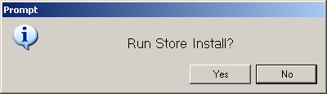
- Click Yes to restart the Store Install process.
- The following screen will appear:
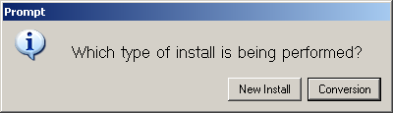
- Click New Install.
- The following confirmation will appear:
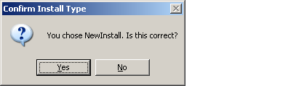
- Click Yes to continue.
- The Shop Information screen will appear:
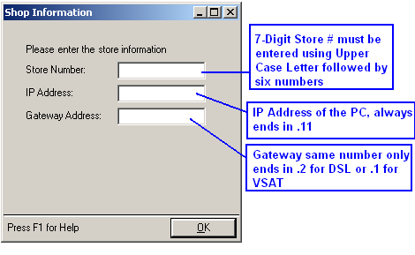
- Click in the Store Number field.
- Using ALL CAPS Key in the Store Number.
- Key in the IP Address of the PC (refer to Install Report from IBM).
- Key in the Gateway Address.
- Click OK when done.
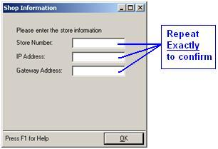
- The following screen will appear and require you to reenter the Store Information a second time for confirmation.
- Re-enter the same Shop Information using all Caps on the Store Number once more to confirm.
- Click OK. Note: If any mismatch of the entries are detected the following message will appear, click OK, You will be returned to the Shop Information screen and will be required to reenter the Shop Information until it is confirmed to match.
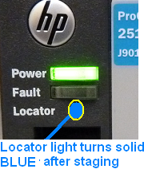
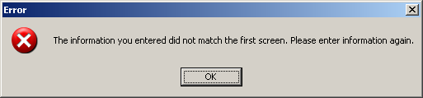
NOTE: the HP ProCurve will be staged by now
- Once the Shop Information has been entered, click OK to continue the Store Install process.
- The Store Install process will ping the Router to confirm communication and then ping a known site to confirm the Broadband connection is working properly. You will see a screen similar to the following:
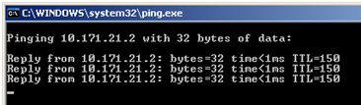
Note: Should this fail, the following screen will appear:
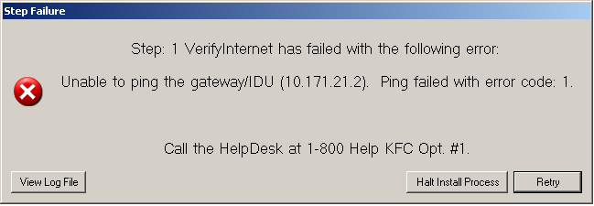
Contact the Install Contact to report this issue (not the generic Help Desk # listed).
- Once a working connection has been confirmed, the Store Install process will continue on running several automated steps.
- The following screens will appear while establishing a connection: (This step is doing the Manual Poll from Remoteware Server to test the connection).
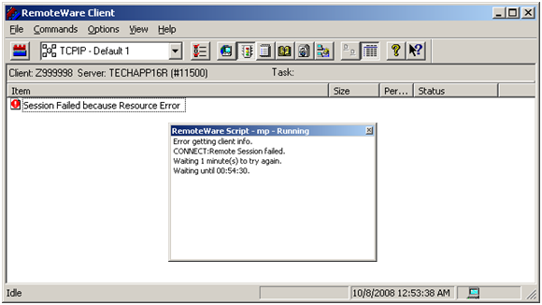
- Once the connection has been established, the following screen will appear: (this screen shows the status of the data files being downloaded to the PC.) 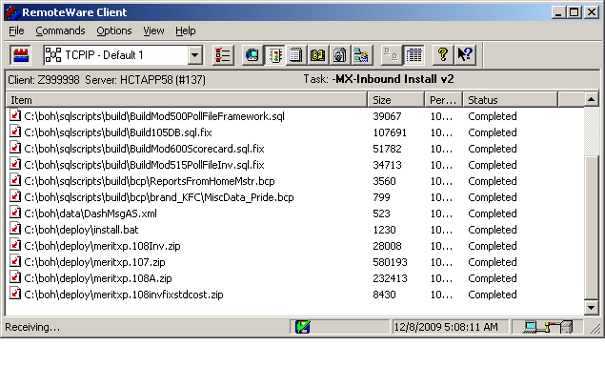
- Once the data files have been downloaded, the Store Install process will continue running several more automated steps. This will take 5-10 minutes.
- The following screen will appear: Click OK. The Install Process will stop and exit.
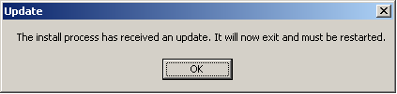
- Double click the Install icon from the desktop to restart the process.
- The following screen will appear: Click Yes to continue the process.
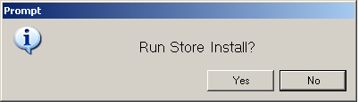
The following screen will appear showing that the store data package is being downloaded. 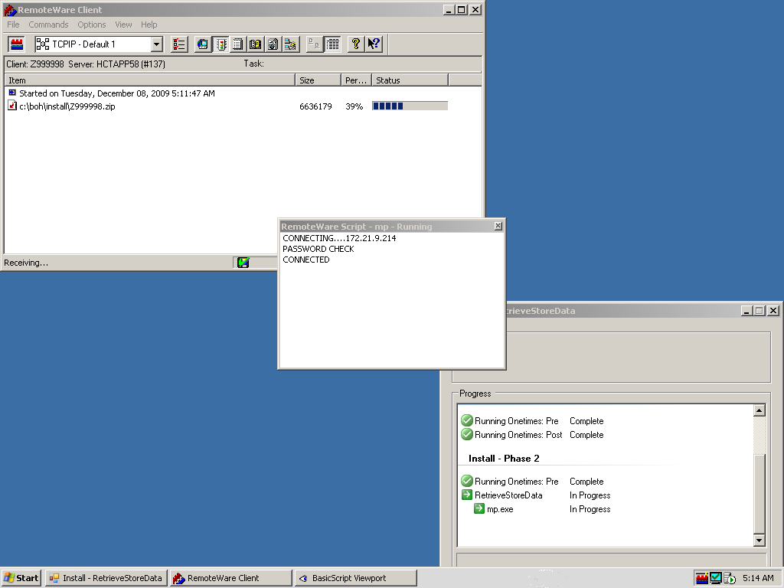
Once the store package is downloaded, the install process will continue to run several automated steps. This may take 15 minutes or longer to complete.

Staging ALL POS on front counter
You will now begin staging the terminals all sitting on the front counter.
Both IBM Ex6 and Ex6 Lite’s should default to the proper boot sequence out of the box – NETWORK as First Boot Device. (If you need to check this or have errors refer to the Appendix at the end of this document.) The DATE must match the DELL PC however.

Follow the on-screen Staging instructions exactly. Failure to follow the instructions exactly will cause the POS terminals not to load and the Staging process to fail
- Ensure ALL POS terminals (and Epic Controllers) are turned off.
- Note: No keyboards, Printers, or Cash Drawers need to be attached to the POS terminals at this time.
- At the Stage Devices screen, uncheck the Auto Stage box as you will be staging all terminals simultaneously.
- 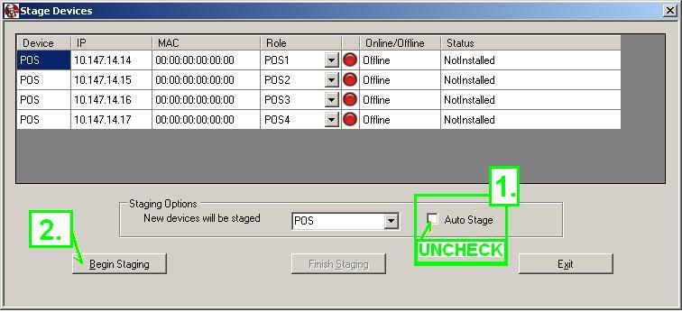
- Next click on the Begin Staging button
- When the StageStuff dialogue appears, click Yes 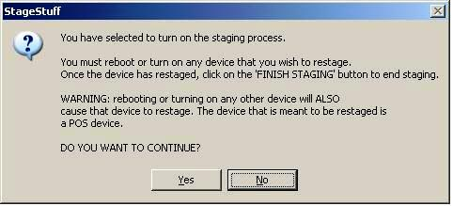
- POWER ON ALL TERMINALS ONE AT A TIME, BEING SURE TO VERIFY/SET the DATE TO MATCH THE DATE ON THE DELL PC. The time itself is not important at this point – only the day/month/year must match the BOH PC.
- 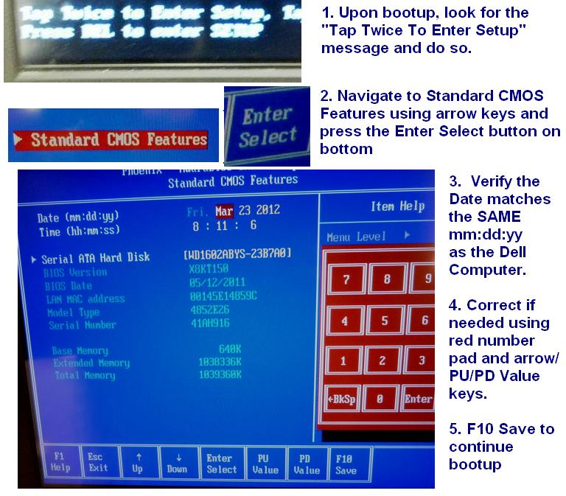
- Save and exit to reboot and begin staging process.

- Each terminal should have Ghost running. It will take about 10-15 minutes for each terminal to ghost. (Refer to POS Troubleshooting if Bios check is needed)

- Once the Compris POS image loads, the 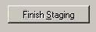 button will change from grayed-out to black lettering. Click Finish Staging to initiate a POS reboot to the Terminal Assignment screen seen below:

- 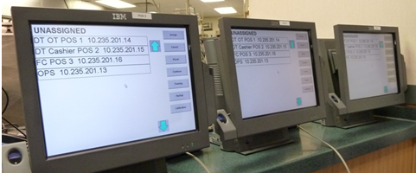

- The IBM terminals should come up with the Terminal Assignment screen with “UNASSIGNED” at the top.
- Using the POS# stickers on top of the screen placed earlier for reference, touch the corresponding terminal number then the ASSIGN button in the upper right hand corner. After several seconds the terminals will restart to t
- Note: If “Not all terminals are on the network – could be network or hardware problem” appears, call the Implementation Contact as needed to troubleshoot problem and get the terminals up.
- Once Terminal Staging has been completed, press Exit for the terminals to reboot to the Cashier On screen.

Make sure all the pos have completely loaded and are all on the Cashier ON screen. Failure to do so and shutting down the BOH PC when the POS have not been completely loaded will cause issues later in the install process. 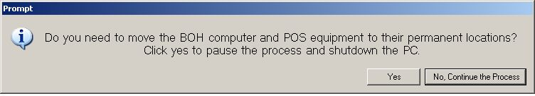
44.) Click YES once the POS have all loaded and are displaying the Cashier ON screen, this will shutdown the BOH PC, then it is safe to power off the POS equipment and move to their permanent locations.

Deinstalling old POS
- De-install any existing External credit card terminals, Power supplies, and Pin pads
- De-install old POS terminals, receipt printers, cash drawers, packing monitors, controllers and bump pads, monitors, printer and keyboard and hub.
- Place all equipment in a dry foods box and place in the office for the Manager.

Move Equipment to Permanent Locations
***REMEMBER to connect POS & MWS to the UPS boxes and refer to Configuration sheet to ensure terminals are in correct place. *** Refer to Data Cabling section (Pg 29) for wiring details and POS Installation (Pg 31) for terminal installation details ***
45.) Once the BOH, OKI Printer, and POS equipment have been moved to their permanent locations, power on the BOH and then power on the POS. Once the BOH has returned to the desktop, double click the install icon to restart the Store Install Process. The following screen will appear:

Click -- No, Continue the Process.

The Store Install Process will run a test to confirm broadband communication then install the BOH Printer.

Install BOH Printer
The following Prompt will appear to install the Printer.
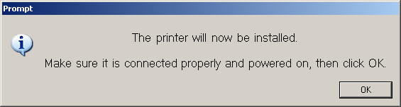
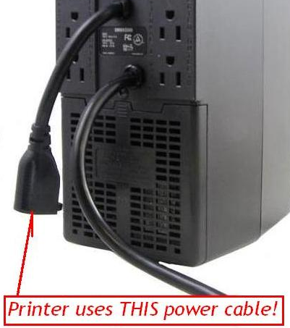
Make sure the Printer is powered on (using the hanging female power cable from the UPS 800- see picture), the USB cable is connected to the DELL PC, and has paper in the tray (the tray on OKI’s will hold a full ream).
Be sure to release the scanner lock!
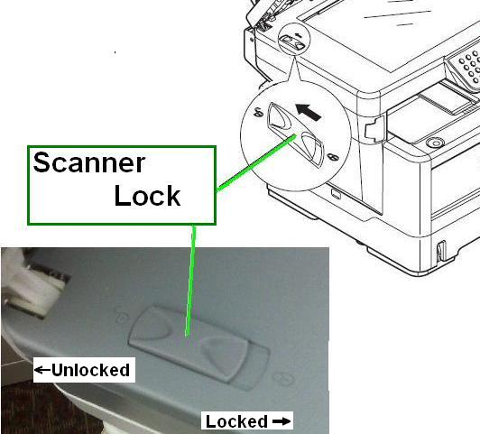

USB cable for the printer should be connected as follows:
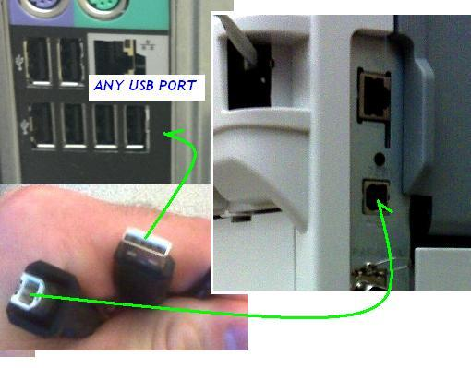
Connect phone lines as shown here:
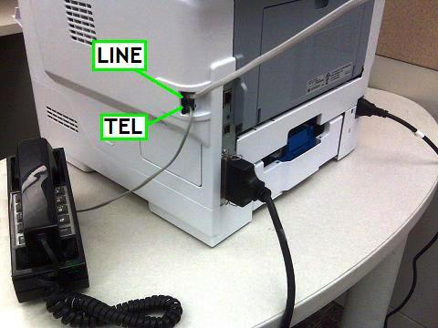
47.) Click OK and follow the steps listed below (be careful NOT to hit OK too soon!)
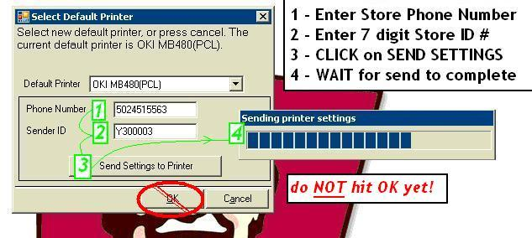

48.) After about a minute the click OK on the prompt as seen here:

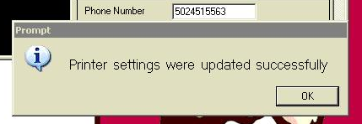

49.) The following screen will appear: Click OK to print the test page.

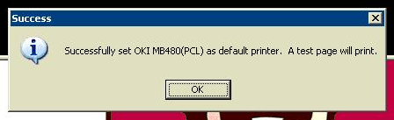
50.) Send Test Fax to 502 874 7660 including your name and store ID#.
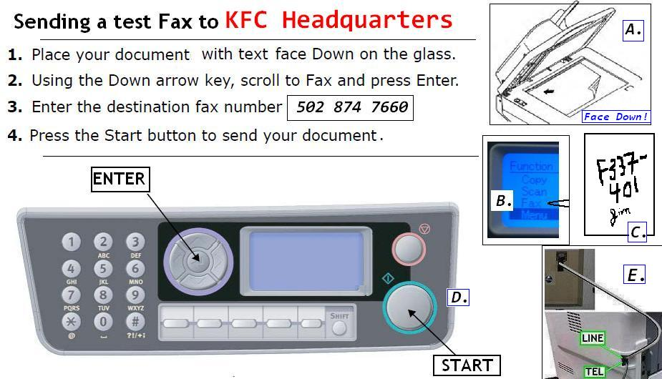

50.) The following screen will appear to confirm the Store Network is installed properly, the BOH/Hub/POS/Epic and Broadband are properly connected and all the POS are on the Cashier ON screen (ePics are connected but still powered off).
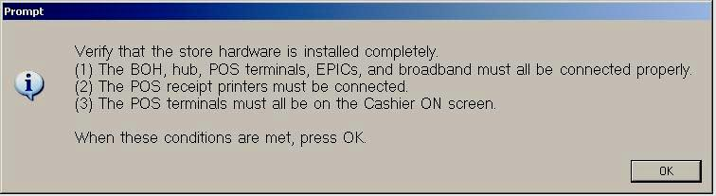
52.) Click OK when all conditions are met.

SOD on POS
53.) The following screen will appear while Start of Day is running on the POS. This could take 10 minutes. 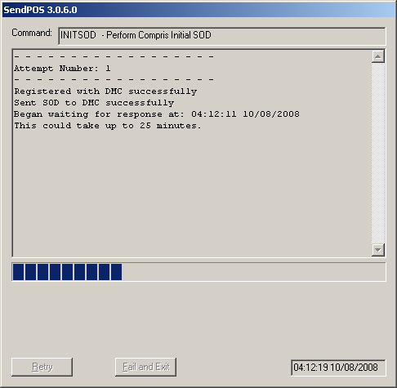
54.) Once the POS SOD has completed the following screen will appear.

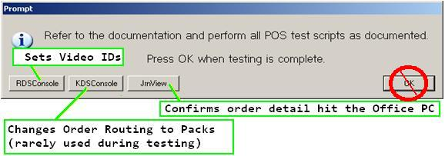
DO NOT PRESS OK UNTIL THE POS AND KDS TESTING HAS BEEN COMPLETED!

KDS – Kitchen Monitor Installation
- Install the KDS monitor brackets in the positions indicated on the placement diagram and or the franchise representation.
Note: If the monitor bracket is not in an area where someone could hit their head on it and get injured, it should be installed where the bottom of the monitor is approximately eye level. It can be mounted a little higher, since the monitor can be tilted.
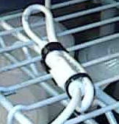
Note: If it is near where someone could bump their head and injure someone, the bottom of the monitor bracket should be at least 72”.
Pigtail zip-tied
- Install the stainless steel Bump Pad Brackets and mount them below and near each Video Monitor.
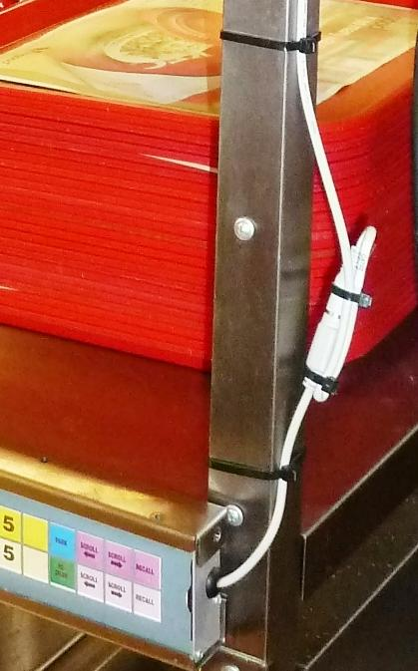
Note: when you have a kitchen pass thru window, the Bump pad brackets can me screwed to the stainless steel windows sill/counter lip. You will need stainless steel self tapping screws for this.
Note: when you have the grill area in the front of the store, it should be mounted where it can be easily reached.
- Secure the external Pigtail connector by using two cable ties. Fold the longer cable back onto the shorter cable and then fasten it. Trim the excess zip tie cable and make sure there are no exposed sharp edges. (A lighter may be used to melt any sharp tip points on the cable tie)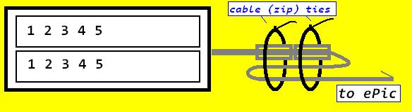
- Install the 17” Video Monitors, QSR ePic Controllers and Bump Pads. Match Video position (2, 3, 4, 5, etc.) according to configuration sheet. The controllers will need to be placed in the controller brackets provided.
Note: the controllers should be installed on the side of the monitor away from the customer side.
Note: Be sure to secure the monitors into the ceiling/wall brackets by tightening the 2 side bolts and top bolt.
- Connect blue Ethernet patch cords from the “Network” port of each QSR ePic Controller to the RJ45 wall jack.
- Connect the Bump Pad cable to the “Keypad” port on the QSR ePic Controller. Using cable ties loop back the Pigtail connection to ensure it will not pull out. Run Bumpbar cable to ensure cabling does not interfere with store work space.
- Install the Bump Pads into the Bump Pad Bracket.
- After all data cabling is ran and all equipment is installed in the proper location leave all equipment powered off.
- At the PC when it boots up, a message will appear: Is the new store system installed completely – YES- NO”. Click on YES and the following screen will appear:
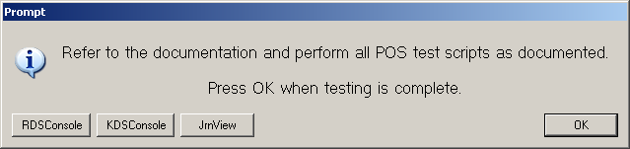
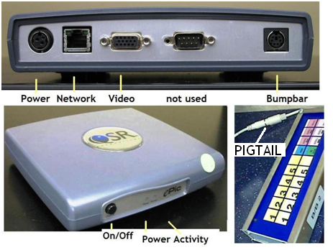
Once all devices are connected to network MAKE SURE VIDEO CONTROLLERS ARE NOT YET POWERED ON
Click RDSConsole

Setting IDs on ePics
- Power on only ONE KDS ePic controller and Pack monitor. The device ID should default to Device Id 16. Using the Configuration sheet as a guide set the ID on the ePic box using RDS Console in the BOH. Do this ONE AT A TIME. Be sure and power off each Epic after ID is set to AVOID TWO LIKE IDs on the network at the same time.
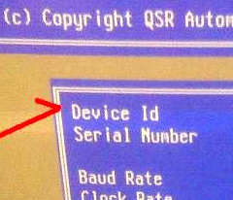
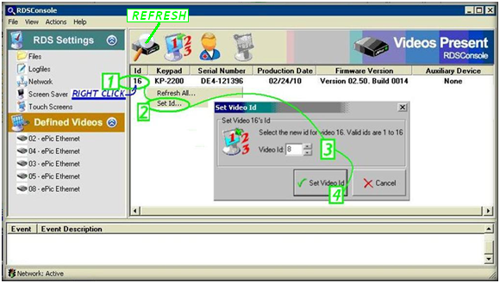
- Repeat above steps until all Pack Monitors have their proper IDs.
- It is safe to power back on all ePics once all have proper IDs for testing.
- Click on Actions/Refresh videos and the screen will show the ID’s of all Kitchen Monitors that are successfully communicating with the PC. All Bumpbars should show a Serial Number (versus “None”)
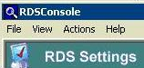
- If any ePics or Bumpbars are missing - troubleshoot the wiring and hardware, especially the controller power supplies and again click on refresh all.

VIDEO DIAGNOSTICS
- Click on the Action icon.
- Click on “Refresh Videos”. The ID’s of all Kitchen Monitors that are successfully communicating with the Dell PC will display.
- Do the following to run diagnostics for each Kitchen monitor:
- Click on “Actions” from the menu at the top of the screen.
- Click on “diagnostics”.
- Select a specific monitor by selecting its ID from the drop down menu.
- Select “blinking” from the diagnostics panel.
- Go to that monitor and verify that it displays the test pattern.
Repeat these steps for each Video Monitor by selecting the appropriate video monitor ID from the drop down menu.
- Run diagnostics on each keypad (one at a time) as follows:
- Select the specific Kitchen Video Monitor requiring a keypad test. Select the video ID number from the drop down menu.
- Go to that Monitor/keypad location and press each key on the keypad (bump bar).
- The Diagnostics screen on the PC will display Green checkmarks by each working button.
- Repeat these diagnostics for each Bump Pad.
- When all kitchen video monitors have tested successfully, close the RDS console program by clicking on the “X” at the top right corner of the box.
Bump Bar Troubleshooting:
- Make sure bump bar cable is seated well into the controller, the pigtail and bump bar.
- Open up Bump bar casing and verify bump bar cable is plugged in securely.
- Try a different bump bar cable. (Installers should carry extra cables)
- Try different bump bar. (Installers should carry extra Bump Bars)

Ring-up mock orders: TEST POS, MONITORS & BUMP PADS
The terminals should be in place and at the “Cashier On” screen before continuing. All peripherals (Drawer, Printer, etc) should be in place and powered on as well. Number 11 is a test Cashier; the Test Manager Code will be 16 (the Compris Daily Password can be used also). Obtain the Six-Digit Compris Daily password from the BOH PC needed for Cashier Close.
How to obtain Compris Daily Password at BOH PC if needed:
- Click on Start
- Click on Run
- Type in cmd and press enter
- Type “password 1” and press enter.
- Write down the Daily password.
- Type “exit” and press enter to close the command window.

Testing Orders on EACH terminal Overview:
The primary testing goal after POS & KDS load is to test each piece of hardware’s function.
- Can each Terminals ring an order?
- Does the Order hit the Pack Screen(s)?
- Does a receipt print each order?
- Did the Drawer open when Totaled?
- Will the order bump from the Pack screens?
Do the following at the Drive-Thru Order Taker POS to begin:
- Press “Employee Menu”
- Press “Mgr Menu”
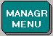
- Type “16” (or the Compris Daily Password and hit Enter)
- Press “CASHER OPEN” in bottom left
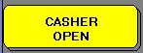
- Type “11” and press enter (2) times
- If “60.00” does not automatically show on the “ENTER BEGINNING CASH” field, enter “6000” and hit Enter. If already present - just press Enter two more times.
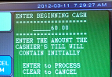
- Press “Employee Menu”
- Press “Clock In For Start Of Shift”
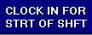
NOTE: You will only have to clock in ONCE, on the first terminal selected for testing.
- Press “11” and press enter
- Press “Return”
- Press the “Casher ON” button located in the center of the screen.
- Type in Cashier # “11” using the numeric keypad displayed on the screen.
The terminal is now ready to take orders.

- The main POS Order Entry screen should appear.
- Ring ANY item (i.e. 2pc ML, Biscuit, etc) and press STORE
- Sign off the Cashier using the Employee Menu/Cashier OFF
- Go to the DT Cash POS #2 and hit Casher ON, 11 ENTER
- Press Recall (the order rang on POS #1 should appear)
- Hit TOTAL and tender the order using EXACT DOLLAR AMOUNT
- Confirm the following occur upon totaling the Drive-thru order:
- A receipt printed with the correct store ID
- The Drawer opened
- The order hit the pack screen
- The Order can be bumped (when the order hits multiple screens -bump at the Pack line(s) first, and the EXPO monitor last)
- Press Employee Menu, Cashier Off, and proceed to the FRONT COUNTER for further testing.
- On the Front Counter POS, Cashier on Cashier 11
POS Testing Flow
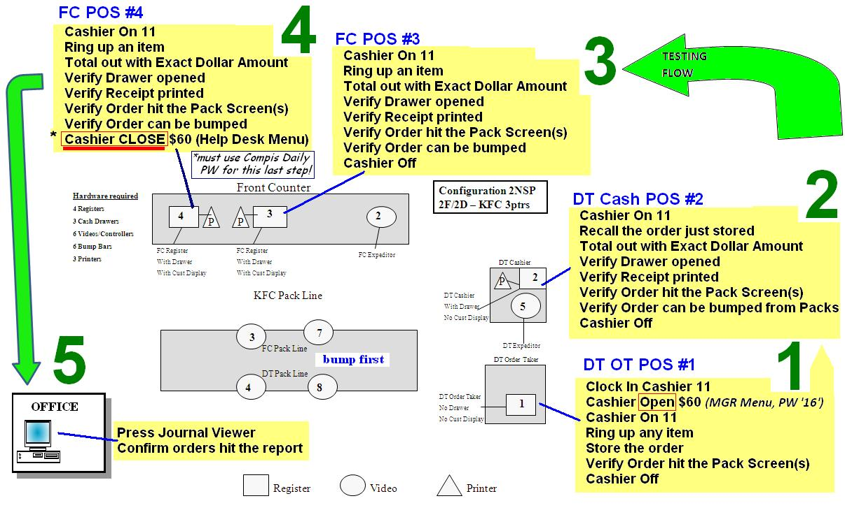
- Ring up any menu item
- Total out with Exact Dollar Amount
- Verify the following occur when totaling a Front Counter order
- The Customer Display showed the price (Front Counter Only)
- The drawer opened,
- A receipt printed,
- The order hit the Pack Screen(s)
- The Order can be bumped (bump from Pack line 1st as Expo will bump all).
- Press Employee Menu and then Cashier Off
- Repeat signing on and ringing test order for any remaining POS.
- On the LAST POS to be tested, do not Cashier Off, instead, press Cashier CLOSE button found under the Help Desk Menu (requires Compris Daily Password to access this menu) ***FAILURE TO “CLOSE” Cashier WILL CAUSE ERRORS AND PREVENT SCRIPT FROM COMPLETING!***
- Enter $60.00 to settle the cashier (a financial report will print on the receipt printer).
If any of these actions do not occur, double-check steps and try again. If necessary, call the Implementation Contact.
Do the following on the Office PC.
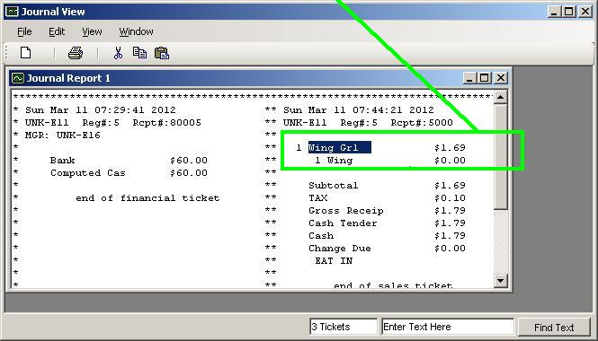
- Click the JRNView box.
- The following screen will appear.
- Click on “generate report”
- Quickly review report to ensure it includes the banks, clock in and transactions rung in testing. Compare to the receipts printed to this report.
- Click “X” to close report
- Click on the “X” in the top corner of the screen to close out journal view box
- At this Prompt, Click on “Ok” when testing is complete.
- At the message “Is testing Complete?”, Click on “YES”
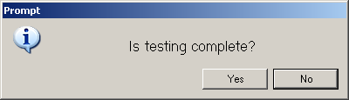
The following screen will appear; this could take 25 minutes. 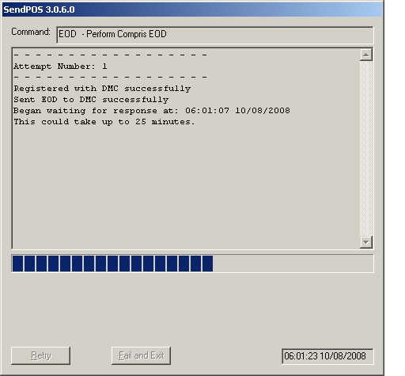
- More processes will display running in the status window.
- Casper (DiskRecovery) will run to copy C: drive to F: drive – This could take up to 20 minutes.
- The PC will reboot and return to the Dashboard Screen.
- Once PC boots up to the dashboard, log in using your supplied password.
- Allow the “Set Conn” script to automatically run.

Instructions for Enabling Pin Pad Software (Ingenico Cashless Payment Devices)
Click CUSTOMIZE/YIS MENU/POS and double-click the Enable PinPads icon 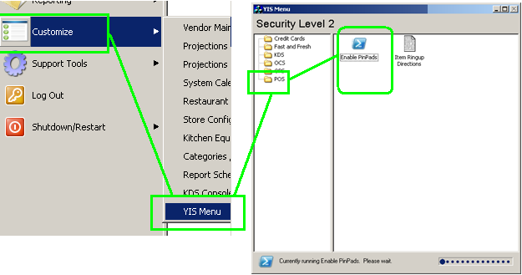
- After Double clicking the Enable PinPads icon the following screen will appear:
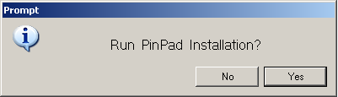
- Click YES to continue the install. The following screen will appear:
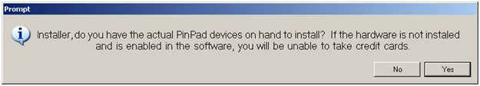
- Click Yes once the hardware has been installed. The following screen will appear: 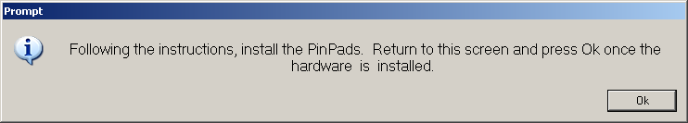
- Refer to the Cashless PinPad Installation Instructions provided in this document on how to install the Pin Pads. Once that has been completed, return to the Back Office and click OK. The following screen will appear:
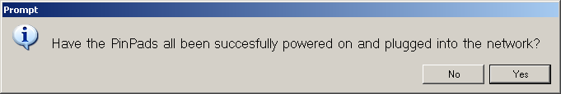
- Click Yes if the all Pin Pads have been successfully powered on and plugged into the network.
- Click OK and you will be returned to Step 7.
- If you Click Yes in Step 8, the following screen will appear:
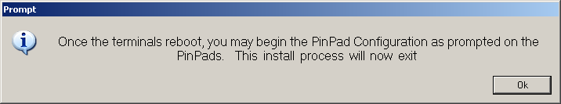
- Go to each POS and complete the PinPad configuration process. 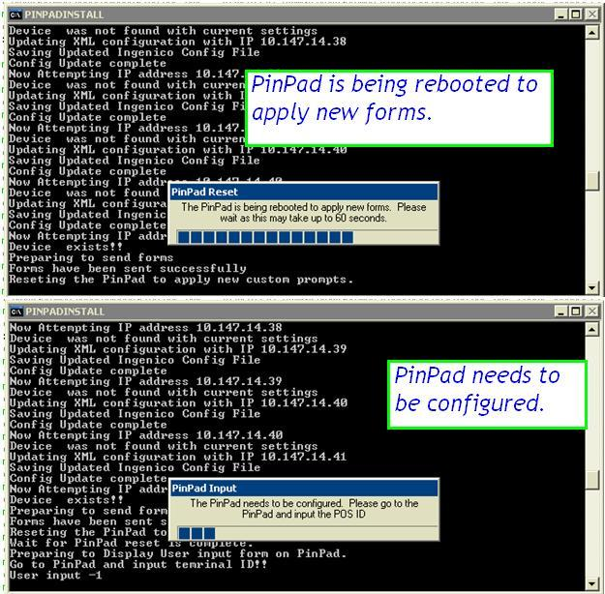
Below are the pictures of what the Pinpads will display:
PinPad prompting for ID to be entered. Press the number corresponding to the terminal number (i.e. POS2 = Pinpad 2)

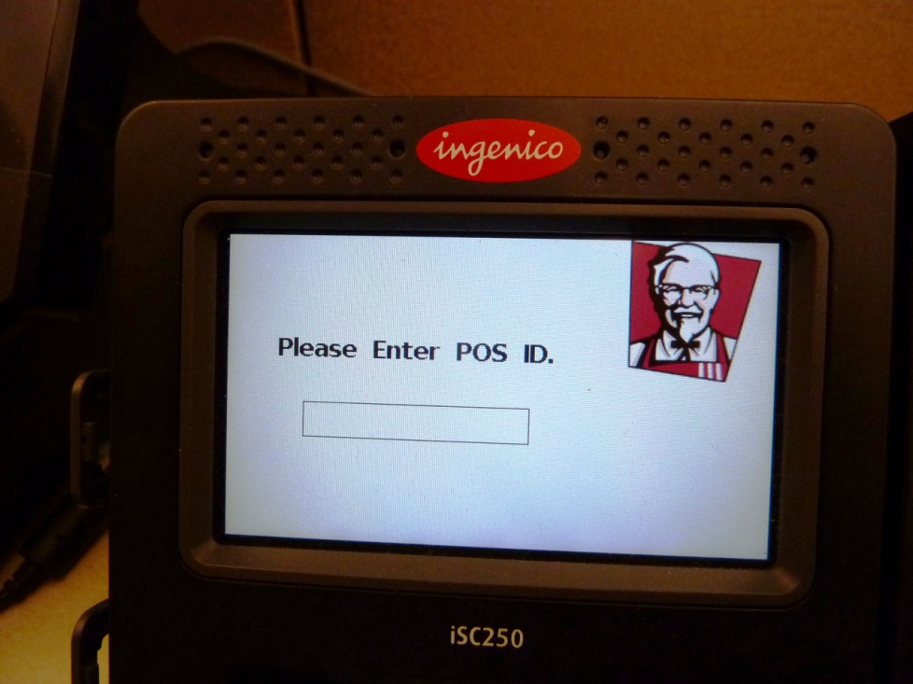

- Once this has been completed return to the back office pc and click OK to exit the install process.

Data cabling
- Install the network cabinet in the Manager’s office. Note the wiring cabinet will hang vertically above the location for the computer at approximately 6” inches below the ceiling. Home Run Cables should be concealed in the wall and enter the cabinet from the rear or through the ceiling and down the wall if necessary. You may need to drill an entry hole in the wall behind where the cabinet will be mounted.
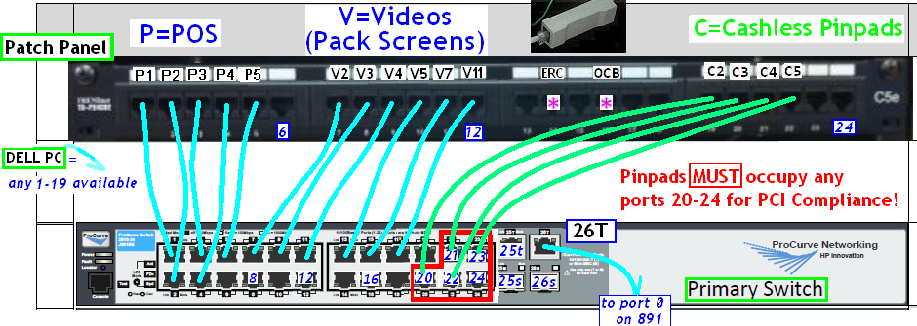
- Run a new network drop for each POS Terminal, Pinpad, and ePic controller back to the patch panel in the network cabinet. Each device will communicate through a three part cable:
- Short patch cable from Switch to Patch Panel
- A long “home-run” cable between the Patch Panel and the RJ-45 Jack
- A second patch cable between the device (POS, Epic, Pinpad) and said RJ-45 jack.

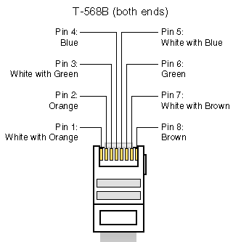
T-568B
RJ45 Jack for POS, Pinpad and KDS: Pull and terminate to 568B standard and test one (1) Cat 5 data cable from the data cabinet location in the Manager’s office to the location of each POS terminal, each Pinpad and each Kitchen Display System (KDS) monitor. Dress new cables to ceiling joists to clear above the ceiling vent, lighting fixtures, etc.
Refer to the attached store configuration diagram for exact device location and numbers.
Terminate the other end of all cables in the patch panel provided in the Wiring Cabinet. Refer to Diagram above noting ports 20-24 are reserved for Cashless Pinpads. POS & Epics will function in any ports 1-19 but please try to use the ports in order (as shown in Appendix 2) if possible.
Terminate POS and KDS cables to 568B standard.
Label the Patch Panel P1, P2, P3, etc. for POS devices, V2, V3, etc. for all video monitors, and C1*, C2, C3, etc. for the future install of cashless payment pinpads according to the store specific configuration sheet. *NOTE the C# should always match the POS # so stores with a Drive Thru Order taker (no cash drawer) will NOT have a C1. Drive Thru stores would start at C2 and FC ONLY stores C1.
Connect standard Ethernet 568B patch cords from Patch Panel to the HP ProCurve indicated in for all POS devices (P1, P2, etc.), Video monitors (V2, V3, V4 etc.) and Cashless Pinpads (C1, C2, etc.).
Test all wiring end to end from Patch Cords at Patch Panel through the building wire to Patch Cord at device end in the restaurant. POS and KDS wiring should pass standard CAT 5 Ethernet tests.
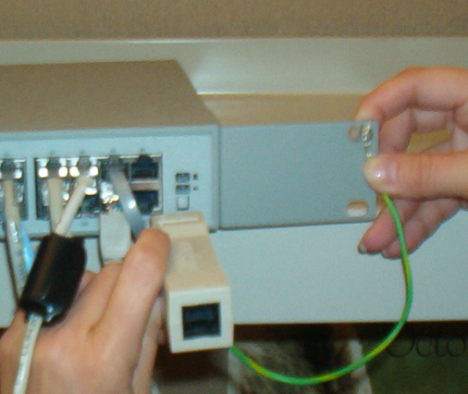
Order Confirmation Board Surge Protector: (when present) Install RJ45 Surge Protector to any available 1-19 port on the primary HP ProCurve switch (refer to Appendix 2)
(this surge protector can be left in the cabinet for future installs such as ERC or an OCB if not needed at this time)

Back Office Installation
- Using existing desk space and shelves, install the NEW Dell MWS PC, the printer, and the Tripp Lite 800UPS. (see diagram in Appendix 1)
2) Adhere the protective keyboard overlay to the keyboard if not already done.
Hook up all equipment as follows:
3) Plug the TrippLite 800UPS into an IG outlet (usually colored orange)
4) Plug the following into any of the six battery backed-up outlets of the UPS:
- Dell MWS PC
- DELL Monitor
- Power Supply in wiring cabinet (Both HP Switches should be plugged into the power supply in the Wiring Cabinet)
- Satellite or DSL Router box
5) Plug the OKI Printer into the external dongle from the UPS 800
6) Cable the switch as indicated on the diagram of Appendix 2.
7) Connect the red 75’ CAT5 ‘tester” Ethernet patch cable from the LAN port of the Dell PC to any available port 1-19 on the HP ProCurve switch.
8) Connect the Office printer USB cable to both the Dell MWS PC USB port and printer.
10) If the site has an HME timer that was hooked to the old pc. You will connect the HME DB9 Serial cable to COM1 on the DELL MWS PC using the DB9 surge protector.

POS Installation
- If the Drive thru has a sliding glass window, the Drive Thru cashier will be installed on the side of the window that opens up.
- If the Drive thru has a window that opens outward, then the Drive thru cashier terminal should be installed on the opposite side of the pop machine.
- IBM 4852 Ex6 Installation Instructions [x: e26 =526 & e66=566]
- Set the new register on the counter keeping the front edge of the screen even with the edge of the counter. (The front counter registers have the display on the front of the register.)
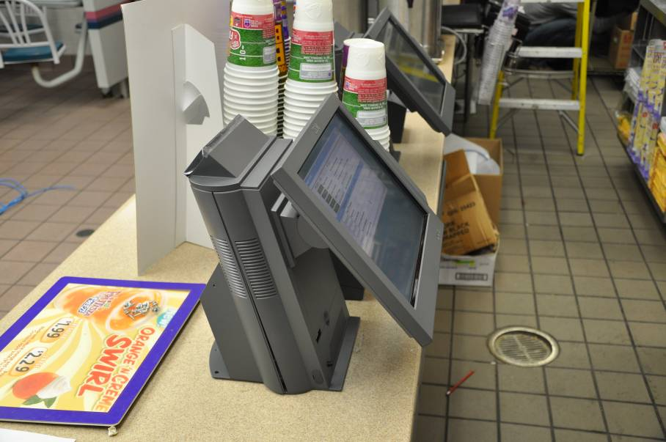

- Open the back of the register to expose the ports. Press the latch at the top to remove the cover.
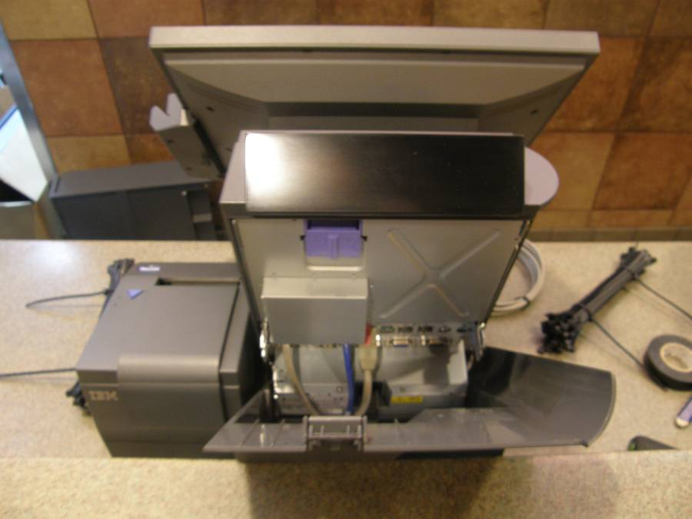

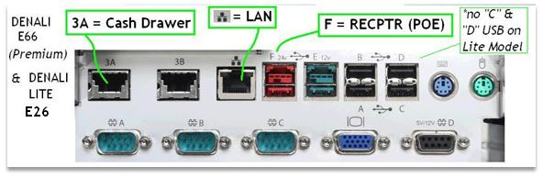
- Install the cable adapter cartridge on the bottom of the printer. Turn the printer over and insert the cartridge as seen below. Then connect the printer cable to the cartridge as pictured in the following four pictures:

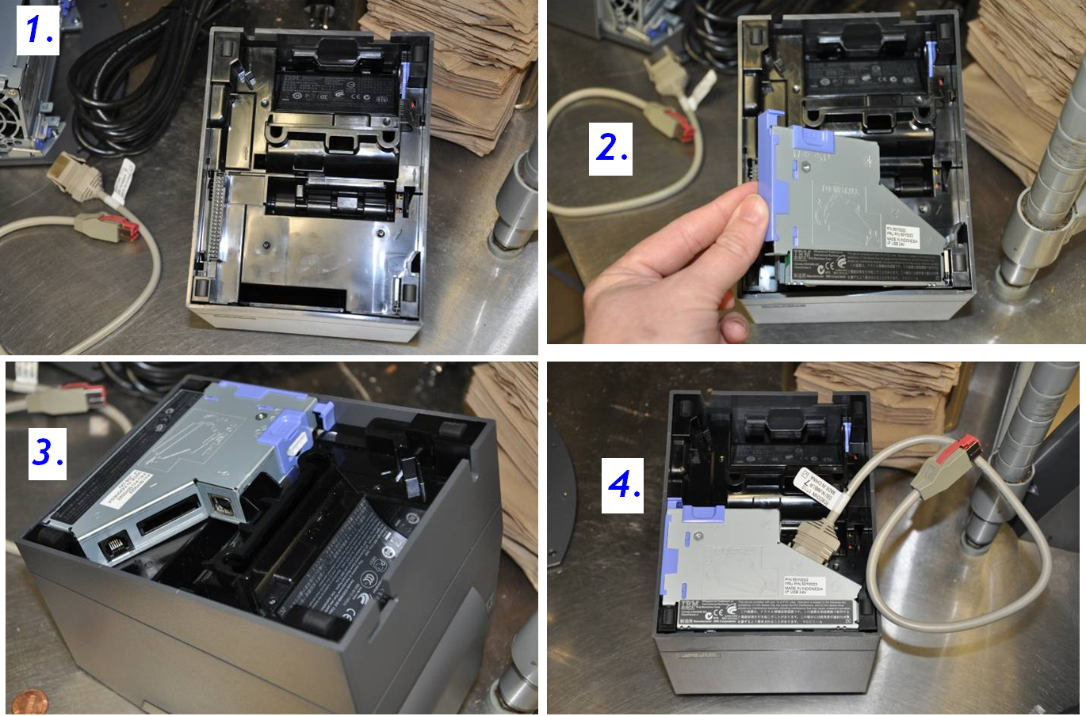
- Install the Cash Drawer under the counter. (Cash Drawer will usually only be installed on one Drive Thru Register. Stores with two windows would have two.)
Cash Drawer Brackets
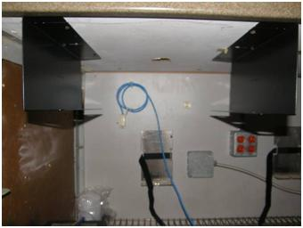
- Install the Cash Drawer Brackets first. Make sure to keep the two brackets even. This is very important at the end of the Cash Drawer installation. The goal is to have the front of the cash drawer even with the front of the counter. (Tip: Install one side of the bracket first. Then slide the cash drawer in that bracket. Slide in the other bracket to fit tightly against the cash drawer. Use a pencil to mark down the outer side of the un-mounted bracket. Install the other bracket using your previous mark. Slide the Cash Drawer into place.

- Connect the Cash Drawer Cable to the back of the Cash Drawer.
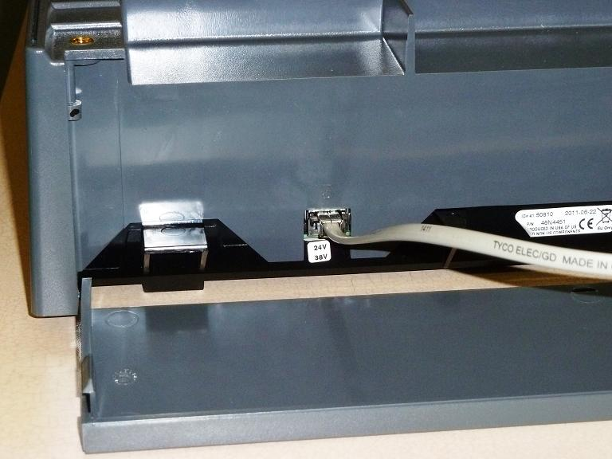

- There are two holes on the cash drawer that match up with two holes on the brackets. (If you have the brackets even they will match up.) Using the two screws that came with the cash drawer, insert the screws thru the bracket into the cash drawer. This is very important and must be completed. 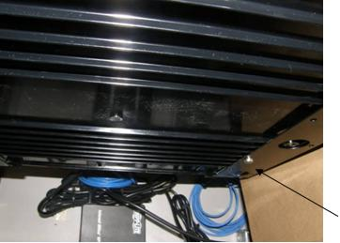
- Connect all cables to back of the register.

- Use the cable bar at the bottom of the register to rout all cables. If possible cables should not be visible to the customer.
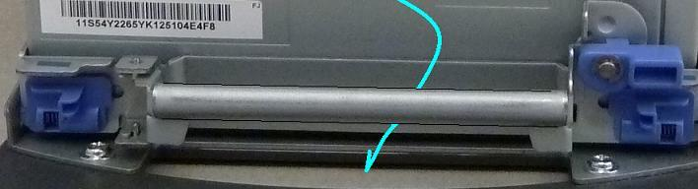
- Once you have completed the connections, reconnect the back of the register.
- Install the UPS connect all power cables to the Battery side: POS, Receipt Printer, and Cashless Pinpad.
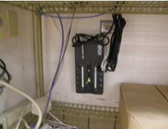
Each POS should have its own Tripp Lite 550 UPS
- Use template and two screws to attach the UPS under the counter high enough that they will not get splashed with water during regular restaurant cleaning. Important: Make sure the screws do not protrude thru the Front Counter facing.
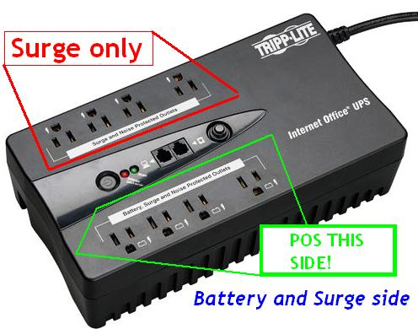
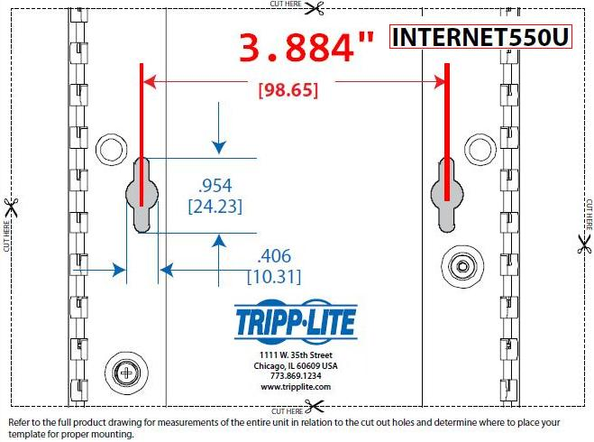
- Plug the Terminal, Cashless Pinpad, and Receipt Printer into the battery side of the UPS.

- Label the RJ45 jacks using a permanent marker for each POS, ePic controller, and Pinpad device. Stickers should NOT be used on the jacks as they will fail over time. Use green marker for Pinpad jacks, black on the POS & Video jacks. Examples: 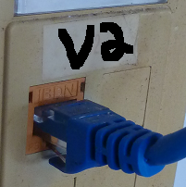
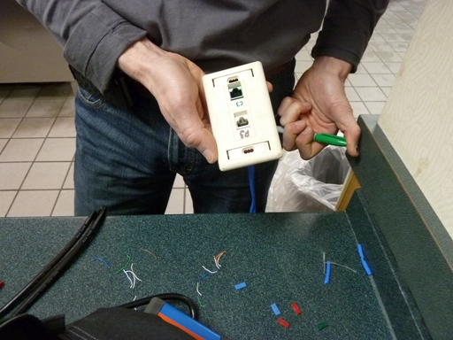

Cashless Pinpad Kit Hardware Install
The Pinpad kit contains a 1.5’ green LAN cable and matching green RJ45 jack as seen below. It is CRITICAL the this green cable be placed in ports 20 through 24 on the 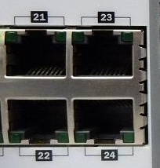
HP ProCurve as indicated in the Wiring Cabinet Diagram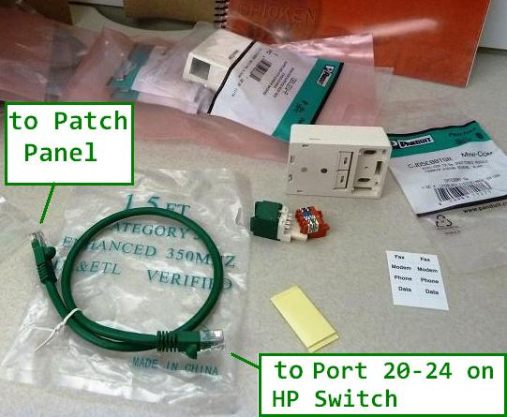
From the Patch panel a homerun cable should be run alongside the POS homerun cable to terminate at the supplied RJ-45 duplex jack casing. There may be instances where the existing wall plates may be used in place of the supplied jack. In the following two examples, using the supplied jack would not be necessary as the existing wall plate jacks were in good shape:
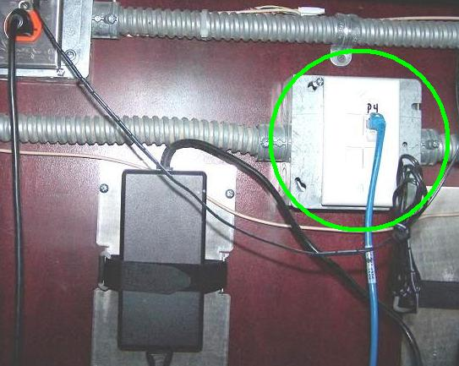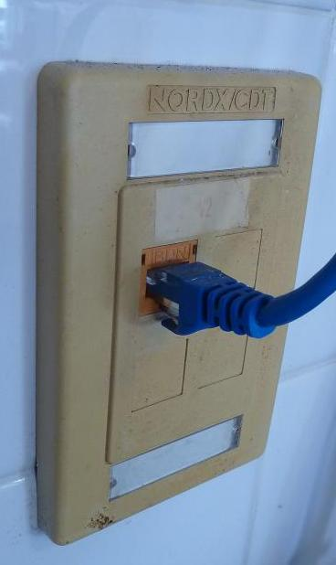
Regardless of which jack is used(new or existing), the ports should be clearly labeled with C# and P# where the # equals the POS# the jack is serving. A 10’ Green LAN cable will connect to the cashless pinpads.
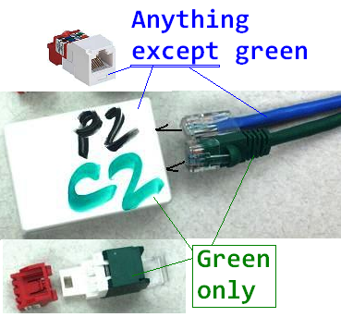
Be sure not to use the supplied dual sided tape by itself to hold the jack in place as it will eventually become unglued and fail. Two screw holes should be used for each jack placed. Label the duplex jack with a permanent marker as it will outlast any label or sticker. The numbers need to correspond to the POS number served. The sample jack above could serve a Front Counter POS #2 (in a “Front Counter Only” store) or a Drive-Thru POS #2. A Drive-Thru Order Taker will never have a Pinpad as it does not tender orders.
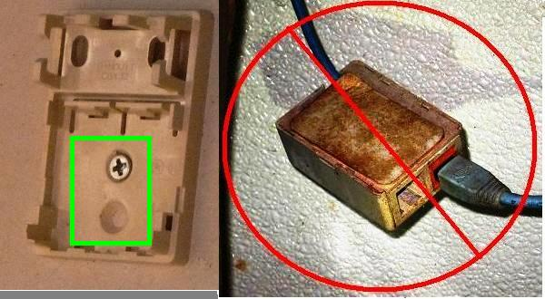
Each POS with a cash drawer should have its own cashless pinpad assigned to it. The front counter cashless pinpads have an Ingenico base that needs to be assembled. Each base has four screws, four caps, and a 3M peel-off base. Affix each base as the following diagram shows but leave the 3M sticker cover on until placement (after all wiring and setup is complete):
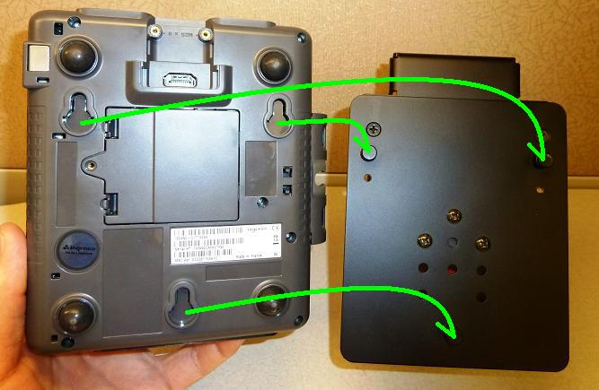
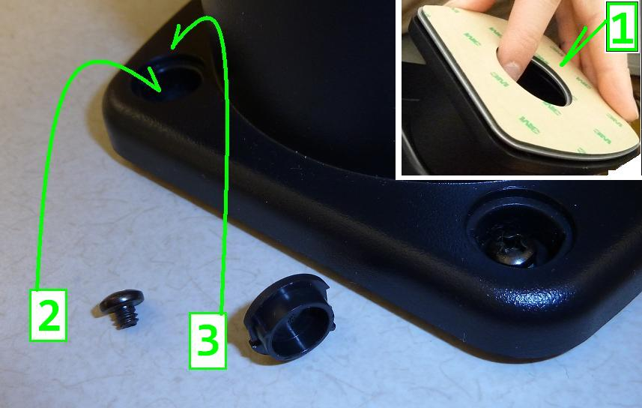
The front counter pinpad fits on top of the base. When the optional lock is ordered, the pinpad should be locked in place after cables are attached.

The keyed removable lock is seen here (hyperlinked plays video):
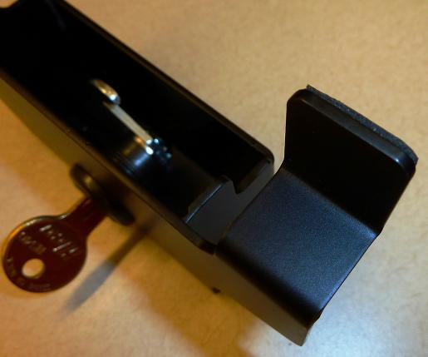

The drive-thru pinpad does not have a base and should be positioned so that the cashier can hand the device to the customer in their car outside the window. Use the supplied bracket to dock near the drive-thru window.
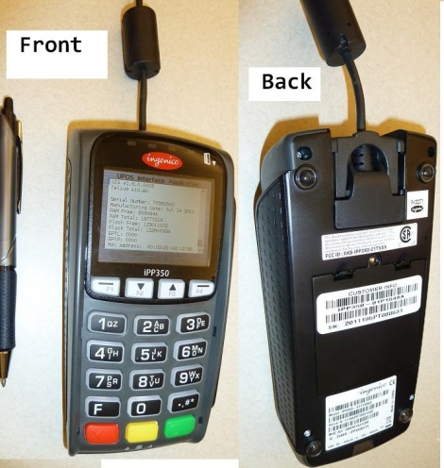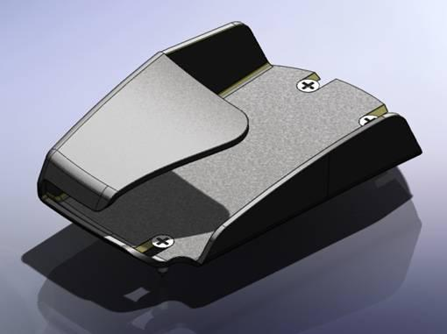
The power-LAN cable for the device should connect to the pinpad itself, the 10’ green LAN cable, and the power cable as seen in the following picture. The cables for Drive-Thru and Front Counter are identical. This Ingenico 8V-2A power cable connects to the battery side of the TrippLite UPS.
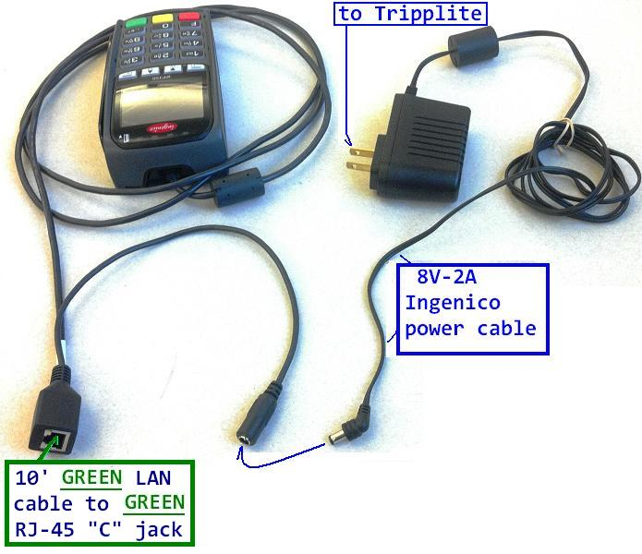
The front counter pinpads need to be near the register they are assigned to and positioned so that they rotate in a fashion that both the customer and the cashier can access them. (Cashiers may need to assist a customer or load a gift card).
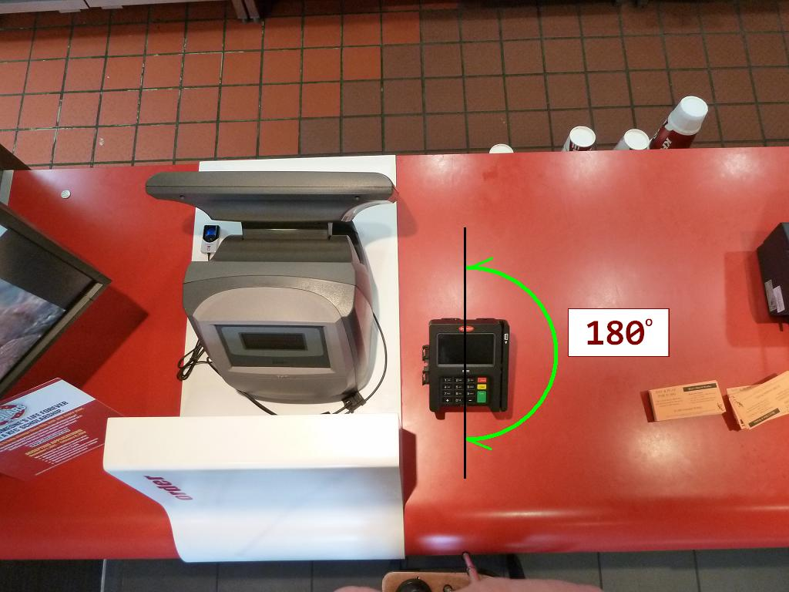
The power cable for the pinpad needs to be looped before being zip-tied into place so that it does not easily pull loose. The cabling should be zip-tied back out of the way of any storage bins or moving obstructions.
Figure 1 Figure 2
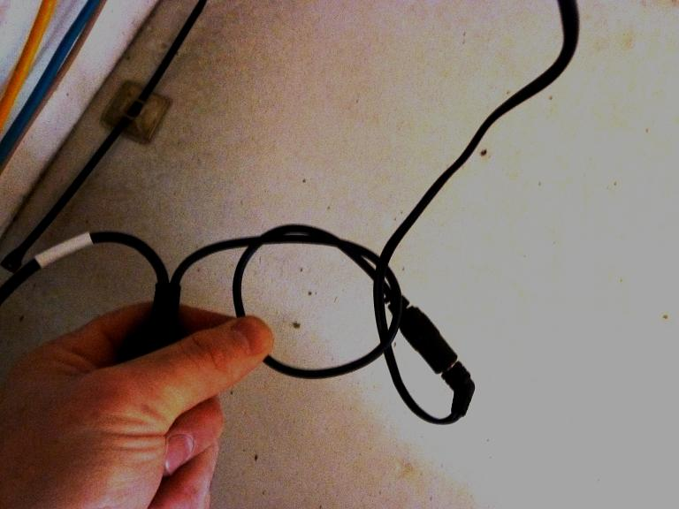
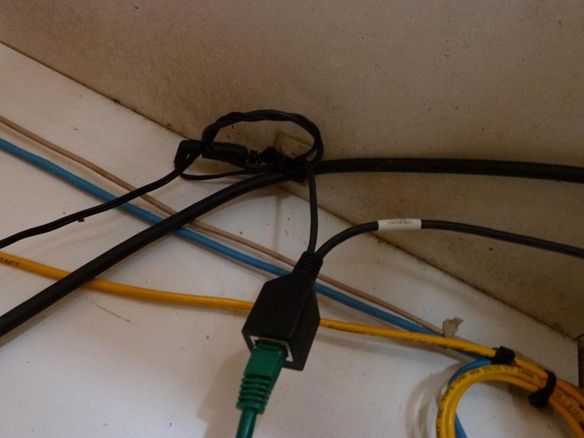
As previously stated, the duplex jack comes with dual-sided tape for placement, but it is imperative the jack is screwed down in place for long term stability.

Configuring OKI MFP 480 password, fax, ring response
Before using this MFP, a few basic settings have to be carried out.
Ensure that you have the relevant permission/PIN numbers before starting.
The Factory set default passwords/PIN are:

Administrator aaaaaa
PIN 000000
Network (web page) aaaaaa
- Press the large round button with a green ring around it to bring up the menu.
- Select Menu and press the enter button
- Select 'Printer Menu' and press the enter button
- Select 'Printer Adjust' and press the enter button
- Select 'Personality' and press the enter button
- Select 'IBM PPR' and press enter button
- Use the Left button to return to the root menu
- Select Admin Menu and press the enter button
- Enter the password 'aaaaaa' by selecting the 'a' and pressing the enter button 6 times
- Select 'Done' and hit the enter button.
- Select 'Settings' (last menu pick) and hit Enter
- Select 'Save Settings' and hit Enter, after a few seconds it will return to the menu
Setting Fax parameters
1. Using the Down arrow key, scroll to Menu and press Enter.
2. Using the Down arrow key, scroll to Admin Setup and press Enter.
3. Using the arrow keys and on-screen keypad, enter the Administrator password. Highlight Done and press Enter.
4. Using the Down arrow key, scroll to Fax Setup and press Enter.
5. Press Enter to select the Clock Adjustment menu.
6. Using the arrow keys and keypad, enter the time and date.
7. Press Enter to confirm.
8. Using the Down arrow key, scroll to Basic Setup and press Enter.
9. Using the Down arrow key, scroll to Country Code and press Enter.
10. Using the arrow keys, scroll to the country in which the MFP is situated and press Enter to confirm.
11. Using the Down arrow key, scroll to Local Phone No. and press Enter
12. Using the keypad or arrow keys, type in the local phone number press Enter if not present.
13. Using the Down arrow key, scroll to Sender ID and press Enter.
14. Using the keypad or arrow keys and the on-screen keypad, type in the Store ID (get from the manager).
15. Highlight Done and press Enter.
16. In the drop down menu, scroll down to the Ring Response and select using the Enter key.
17. In the drop down menu, scroll down to the response time required and select 20 seconds using the Enter key.
18. Using the Left arrow key, return to the top level menu.

Cleanup Tasks
- Place Emergency Network cable kit (spare patch cables) on top of wiring cabinet.
- Place the old equipment in boxes the new equipment came in and the same location where the new equipment was when you arrived. The Over packs can be discarded. If this site had old touchscreen terminals please ensure all terminals are boxed and packed. Any damaged equipment will be billable.
- Let the Trainer manager know they can now proceed with their opening tasks, calling the KFC Help Desk if they have any questions.
- Advise manager that shipping company will arrive between 9am-Noon to pick up the boxes of old equipment. Advise Manager where you placed the old credit card equipment.
- Complete the Installer checklist.
- Updated the packing list with the exact quantities that were installed in the store.
- Verify that all serial numbers have been verified with packing list
- Arrange for any unused equipment to be returned to IBM but leave any unused LAN patch cables at the store (see Step 1) with the manager to keep at the store for future use.
- Arrange for any defective equipment to be replaced.
- Upon completion Take the following Pictures:
    - Front Counter Area: Full view from Dining Room Perspective
                - Cropped view of each Terminal (above the counter)
                - Cropped view of each Terminal (below the counter)
    - Drive Thru Area: Full view from the FC perspective
                - Cropped view of each DT Terminal (above the counter)
                - Cropped view of each DT Terminal (above the counter)
    - Pack Line Area: Full view of Front Counter Side
              - Full view of the Drive Thru Side
    - Office: Inside of Network Cabinet
              - Desk Top (CPU, Monitor, Keyboard, Mouse)
- Make the following status calls:
- Call the IBM installation office phone and give status of installation
- Call the KFC Install Desk 502/874-1880 for a case number for sign off. (No sign off case number = no payment)
Below you will find a checklist of some of the items KFC will check before giving a case ID number for sign off:
- Confirm test pings to both Primary (.4) and Secondary HP ProCurve Switches (.5)
- Confirm all cash drawers were tested successfully during test ring-ups
- Confirm all receipt printers printed a receipt during test ring-ups
- Verify all POS are connected to a UPS - note what type of POS (i.e. Denali e66, Everserv 2000, etc) and UPS (i.e. 550, 300)
- Verify all pack screens have grid showing
- Record if Speed timer was installed and the type
- Verify DELL speaker bar installed
- Confirm Test Fax was sent to # 502 874 7660
- Test Call the site to confirm Ring Response was set to 20 seconds
- Verify PC Time/Date/Time Zone correct.
- Record the OKI serial number & Dell Asset Tag

Trouble Shooting Aids

POS Terminals BIOS Settings
The IBM POS BIOS defaults should be fine but IF for some reason the terminal will not stage over the network, check the Bios. The first boot device should be set to network; the second boot device Hard drive. Upon bootup, look for a message to appear at the bottom on the screen to “Tap Twice to Enter Setup…” - PRESS THE SCREEN TWICE
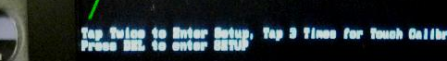

- Using the Down button, navigate to Advanced BIOS Features and press Enter/Select
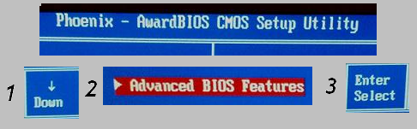

- Verify the first boot device is set to Network and the Second to Hard Disk (3rd & 4th boot devices do not matter).

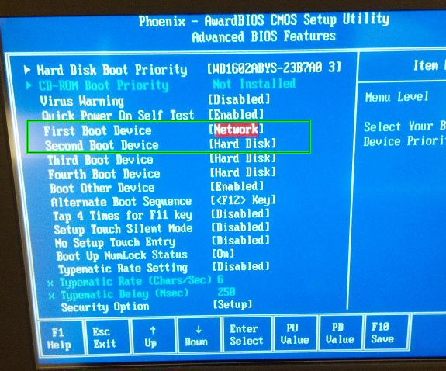
- If the terminal BIOS is still in question it is safe to Load Defaults then re-check boot devices.
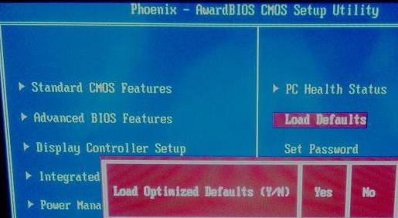

Receipt Printer troubleshooting tips
- Verify the receipt printer is attached to the appropriate terminal and the correct port (“F” for Ex6’s, port 3A Serial)Refer to the site configuration diagram.
- Verify cable connections are secure at the terminal.
- Select Employee Menu from the terminal.
- Press Printer off/on ensure the printer shows online if not press printer off/on again.
- If Printer fails to print swap the printer and cable out with a working printer.
- Report to IBM if necessary for replacement printer and the notify the KFC Implementation Contact.

How to Run Start of Day process on the terminals:
- Press Employ Menu button
- Press Manager Menu button
- Enter the Daily Password obtained and press enter
- Press Helpdesk button
- Press Terminal SOD, the terminal will run SOD and may reboot and return to the Casher On screen.)

APPENDIX 1 Sample Office Layout

APPENDIX 2 Network Cabinet

New Store Office Installation
Patch Panel

Wiring Cabinet
Surge Protector
ProCurve Primary
ProCurve Backup

DELL PC
Note: If there is no PC Rack, arrange equipment on Desk top and/or shelves. Wiring Cabinet should mount about 6”- 10” below the ceiling. Ensure UPS is placed in a dry, sturdy position(not on floor!).
Office Desk Top
Okidata

Printer
Keyboard
Monitor
UPS

NOTE: Both network switches should have power but are not directly linked. Secondary Switch has only one cable connected: 25T to 891 LAN Port 1.
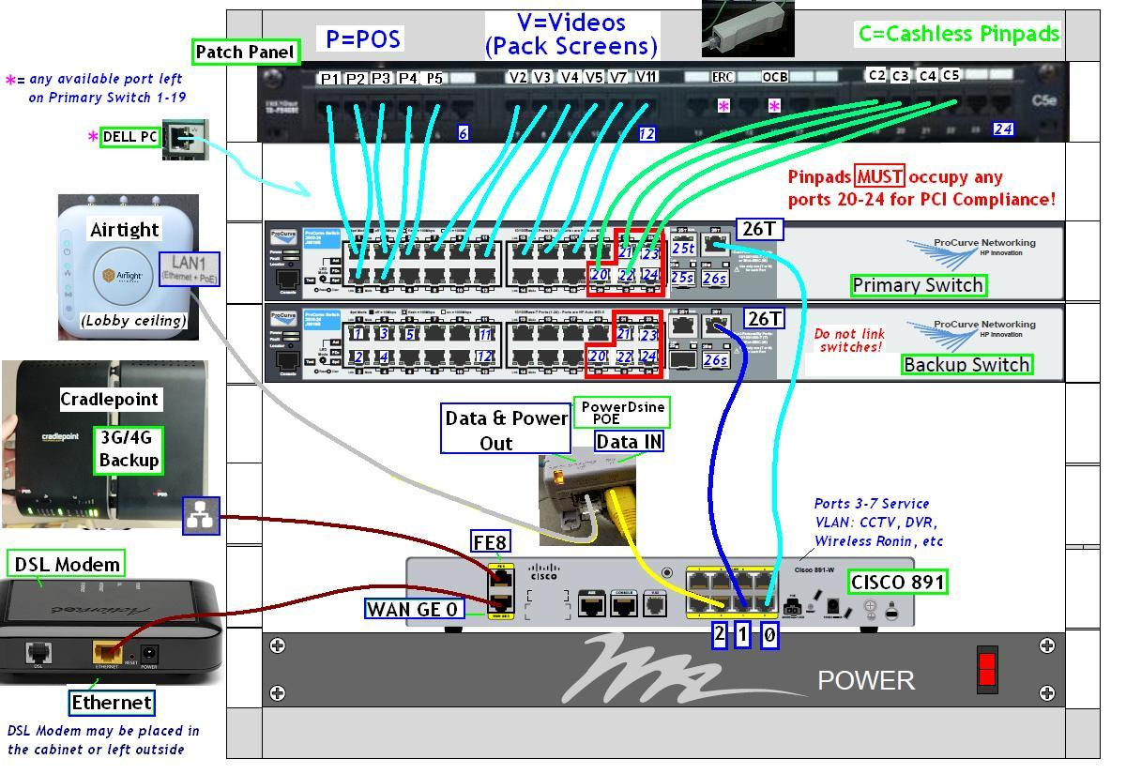
Be sure to connect the Secondary Switch to the Cisco 891 !

APPENDIX 3 IBM POS Ports

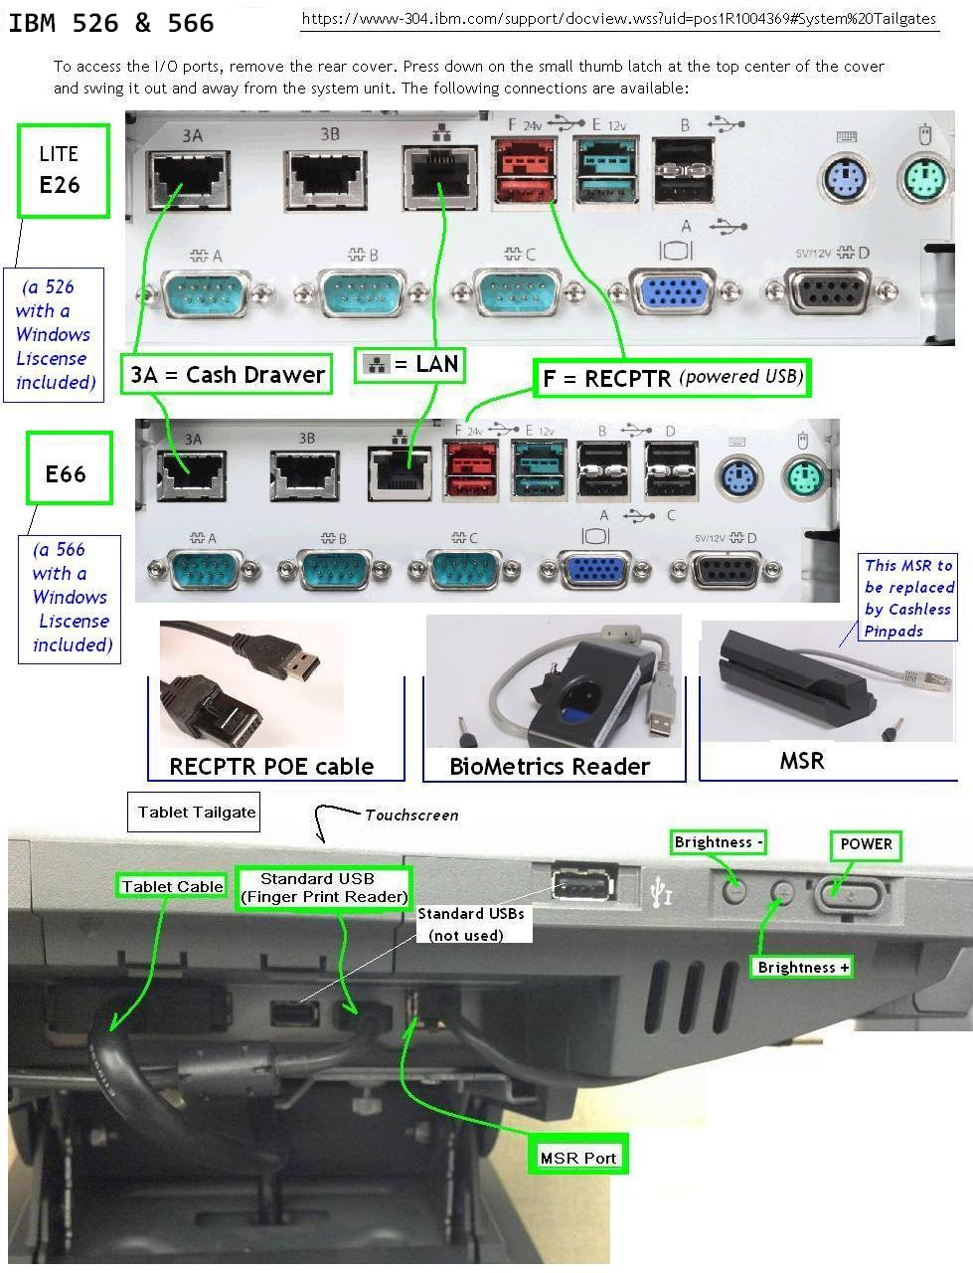

APPENDIX 4 DELL Bios Screen Shot
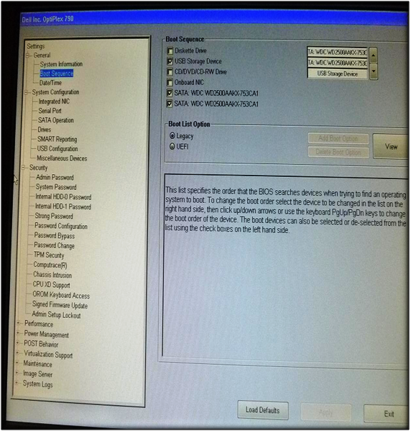

HP ProCurves will be shipped pre-staged up until around May or June 2012
The following screenshots have been taken from Bios version 1.06. Subtle differences are expected (wording/layout) in later mainboard versions and do not necessitate a call – but if unsure, call.
IF the site is Front Counter Only – there is no Store/Recall button in testing, simply cash out the order with Exact Dollar key after hitting Total.
It is possible an error will appear in response to the clock in order, if so, clear the error and proceed to Cashier On for testing

